**Board of Directors Meeting**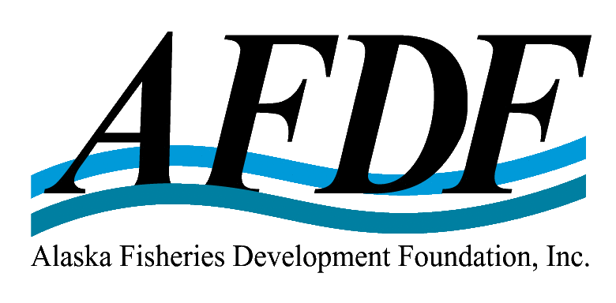

**WHEN:**             Friday, February 24, 2023

9:00 am – Noon, Alaska Time

**WHERE:**       APICDA Conference room

302 Gold Avenue, Juneau, Alaska

Hybrid ZOOM video-conference

*Via computer* <https://us02web.zoom.us/j/81609736809>

*Via phone:* 1-669-900-6833

*Meeting ID:* 816 0973 6809

**AGENDA**

1. Call Board meeting to order
2. Roll call; establish quorum and proxies on file (Julie Cisco)
3. Conflicts of interest declared (none anticipated)
4. Recognize AFDF members/staff/guests present
5. Review & approve agenda
6. Review and approve minutes (2022-10-07, 2022-11-16)
7. Review and approve new membership applications (none) & paid memberships
8. **Staff reports** (65 mins):
   1. Julie Decker, Executive Director, Org Overview (20 minutes)
   2. Ekaterina Ratzlaff, Finance Director (5 mins)
   3. Julie Cisco, Executive Administrator, Membership & Symphony (5 mins)
   4. Hannah Wilson, Development Director, Sustainability Certification & Mariculture

(10 mins)

* 1. Ben Americus, Science Policy Coordinator, Synthesis & contextualization of AHRP (5 minutes)
  2. Ann Robertson, Technical Facilitator, RFM & MSC, cod/halibut/sablefish certifications (10:30am – 5 mins)
  3. Robin McKnight, Mariculture Development Coordinator (5 mins)
  4. Garrett Evridge, Director, AFDF Startup Accelerator (10 mins)

**Old Business:**

1. Discussion & possible action: structure of Industry Advisory Committee (see draft attached)

***Recommended motion:*** *Approve the formation of the Industry Advisory Committee, as outlined, with initial appointments of Cusack, Singleton, and Trident (TBD).*

1. Discussion & possible action: EDA BBB Phase 2 – Alaska Mariculture Cluster - Research & Development Component - Joint Innovation Projects – RFP (see draft RFP – to be distributed)

***Recommended Motion:*** *Approve RFP to be submitted to SE Conference & EDA for final approval.*

**New Business:**

1. Discussion & possible action – investment of Grantham Foundation $1.25M match

***Recommended Motion:*** *Authorize ED to open a new AFDF checking account and CD at First Bank, and authorize signers to be Markos Scheer, Trevor Sande, Chris Mierzejek and Decker.*

1. Discussion & possible action – adhoc committee appointments

***Recommended motion:*** *Approve the formation of a Bylaw Review Committee, and re-activation of Alaska Symphony of Seafood Steering Committee*

1. Discussion & possible action: Crab enhancement

***Recommended motion:*** *Authorize the ED to work with AKCRRAB, act as potential lead entity to receive appropriations request to implement crab enhancement project, and/or support appropriations request to other entity.*

1. Discussion & possible action: Global Seafood Alliance (GSA) Board

***Recommended motion:*** *Authorize Decker to serve on GSA Board of Directors, as nominated by Bill Herzig.*

1. Discussion & recommendations: [ARPA-E summit](https://www.arpae-summit.com/), Decker to serve on panel: Energy & the Blue Economy; input for seafood & aquaculture priority needs.
2. Discussion & recommendations: NOAA Draft National Seafood Strategy (attached)
3. Set date for next Board meeting – May and August, 2023?
4. Adjourn